SDG UNIT-1
Explain waste collection optimization using Machine Learning.

Waste Collection Optimization Using Machine Learning

Introduction
Waste Collection Optimization using Machine Learning (ML) is a smart waste management approach that predicts when and where waste bins need to be emptied. Instead of collecting waste using fixed schedules, ML analyzes historical and real-time data to create efficient collection plans. This reduces fuel consumption, operational costs, traffic congestion, and environmental pollution while improving city cleanliness.

Working of the System
Step 1: Data Collection
The system gathers data from various sources:
- Smart bin fill-level sensors
- GPS data from collection vehicles
- Historical waste collection records
- Weather conditions
- Public holidays and special events
- Population density
- Traffic information
- Type of waste (organic, recyclable, plastic, etc.)

Step 2: Data Preprocessing
The collected data is cleaned and prepared by:
- Removing duplicate records
- Handling missing values
- Normalizing numerical values
- Encoding categorical variables
- Splitting data into training and testing datasets

Step 3: Feature Selection
Important features influencing waste generation include:
- Bin fill percentage
- Day of the week
- Time of day
- Weather conditions
- Location
- Population density
- Nearby commercial areas
- Festival or holiday season
- Previous waste generation patterns

Step 4: Machine Learning Model Training
Different ML algorithms can be used depending on the task.
ML Algorithm | Purpose
Linear Regression | Predict waste quantity
Decision Tree | Classify bins that need collection
Random Forest | Improve prediction accuracy
Support Vector Machine (SVM) | Classify full and empty bins
K-Nearest Neighbors (KNN) | Predict similar waste generation patterns
Artificial Neural Network (ANN) | Learn complex waste generation behaviour
XGBoost | High-accuracy prediction
Long Short-Term Memory (LSTM) | Forecast future waste levels using time- series data

Step 5: Prediction
The trained model predicts:
- Which bins will become full
- Expected fill percentage
- Time until overflow
- Areas with high waste generation
- Number of vehicles required
- Best collection schedule

Step 6: Route Optimization
Once predictions are available, optimization algorithms determine the most efficient routes.
Common optimization methods include:
- Genetic Algorithm (GA)
- Ant Colony Optimization (ACO)
- Dijkstra's Algorithm
- A* Search Algorithm
- Particle Swarm Optimization (PSO)
Objectives:
- Shortest travel distance
- Lowest fuel consumption
- Minimum travel time
- Maximum bins collected per trip

Step 7: Real-Time Monitoring
The system continuously updates using live sensor data.
If:
- A bin becomes full unexpectedly,
- A road is blocked,
- Traffic increases,
the system recalculates the collection route automatically.
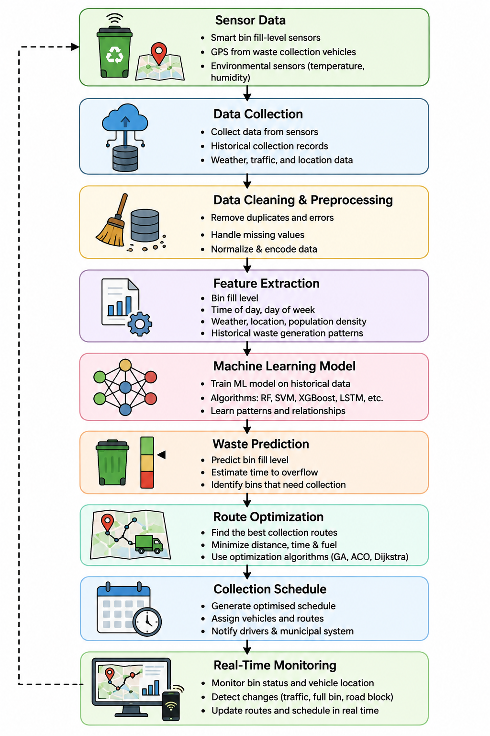

Types of Data Used
Data Type | Example
Sensor Data | Bin fill level (0–100%)
GPS Data | Vehicle location
Weather Data | Rain, temperature
Traffic Data | Congestion levels
Calendar Data | Holidays, weekends
Population Data | Residential density
Historical Data | Previous collection records
Waste Category | Organic, plastic, recyclable

Machine Learning Models and Their Roles
Model | Application
Linear Regression | Predict daily waste volume
Decision Tree | Decide whether a bin requires collection
Random Forest | Improve prediction reliability
SVM | Classify bins as full or not full
KNN | Estimate fill levels based on nearby bins
ANN | Capture complex waste generation patterns
LSTM | Forecast future fill levels over time

Advantages
- Reduces operational costs
- Saves fuel
- Minimizes carbon emissions
- Prevents overflowing bins
- Optimizes vehicle utilization
- Improves worker productivity
- Enables real-time monitoring
- Supports data-driven city planning
- Enhances recycling efficiency
- Increases citizen satisfaction

Challenges
- High initial installation cost for smart sensors
- Sensor maintenance and calibration
- Missing or inaccurate data
- Large datasets require significant storage and processing
- Internet connectivity issues
- Data privacy and cybersecurity concerns
- Need for periodic model retraining as waste patterns change

Applications
- Smart Cities
- Municipal Waste Management
- University Campuses
- Hospitals
- Airports
- Railway Stations
- Shopping Malls
- Industrial Parks
- Residential Communities
- Tourist Destinations

Future Enhancements
- Integration with IoT-enabled smart bins
- Use of Deep Learning for more accurate forecasting
- AI-powered robotic waste collection
- Drone-based monitoring of illegal dumping
- Digital twin models for city-wide simulation
- Integration with autonomous collection vehicles
- Dynamic pricing and incentive systems for recycling

Benefits
Parameter | Traditional Method | ML-Based Optimization
Collection Schedule | Fixed | Dynamic and predictive
Fuel Consumption | High | Reduced
Overflow Risk | High | Low
Route Planning | Manual | Automated
Operational Cost | High | Lower
Resource Utilization | Less efficient | Optimized
Response to Real-Time Changes | Limited | Immediate

Conclusion
Machine Learning enables waste collection systems to move from fixed schedules to predictive, demand-based operations. By combining sensor data, historical records, weather, traffic, and optimization algorithms, municipalities can collect waste more efficiently, reduce costs and emissions, and maintain cleaner urban environments. This approach is a key component of modern smart city infrastructure, providing scalable and sustainable waste management.

